


DEPI Graduation Project

Customer Churn Analysis in Telco Industry

ROUND : CAI4_AIS4_G2
Group : 1

Team Members:
- Mohamed Ibrahim Radwan
- Ahmed Esmail
- Amr el-Azab
- Mohamed Abdul Aziz Aly



Contents
Project Overview: 3
Executive Summary 4
Milestone 1: Data Collection, Exploration, and Preprocessing 5
Milestone 2: Advanced Data Analysis and Feature Engineering 9
Milestone 3: Machine Learning Model Development and Optimization 12
Milestone 4: MLOps, Deployment, and Monitoring 16
Milestone 5: Final Documentation and Presentation 24
Conclusions & Recommendations: 25
Action Plan to Improve Customer Churn Rates 28
Attachments: 30

Project Overview:
The Customer Churn Prediction and Analysis project involves building a machine learning model to predict customer churn. This project utilizes data science techniques such as data collection, exploration, feature engineering, machine learning, and model deployment, with the goal of identifying customers at risk of leaving and enabling the company to take proactive retention measures.

Executive Summary

The Customer Churn Prediction and Analysis project involves building a machine learning model to predict customer churn. Utilizing a dataset of 7,043 customer records, the team executed an end-to-end data science pipeline. This progressed from data exploration and feature engineering to the optimization of a Gradient Boosting model. The final model successfully captures at-risk customers, achieving an F1 score of 0.64 and an ROC-AUC of 0.8392. Key business insights indicate that month-to-month contracts and fiber optic service quality are primary churn drivers. Furthermore, the lack of value-added services, such as tech support and online security, significantly impacts retention. Implementing the recommended action plan will enable the business to take proactive retention measures.

Milestone 1: Data Collection, Exploration, and Preprocessing

  - Objectives:
Collect, explore, and preprocess customer churn data to prepare for analysis and model building.

  - Dataset source:
https://www.kaggle.com/datasets/blastchar/telco-customer-churn/
Sample Extracted:
customerID | gender | SeniorCitizen | Partner | Dependents | tenure | PhoneService | MultipleLines | InternetService | OnlineSecurity | OnlineBackup | DeviceProtection
7590-VHVEG | Female | 0 | Yes | No | 1 | No | No phone service | DSL | No | Yes | No
5575-GNVDE | Male | 0 | No | No | 34 | Yes | No | DSL | Yes | No | Yes
3668-QPYBK | Male | 0 | No | No | 2 | Yes | No | DSL | Yes | Yes | No
7795-CFOCW | Male | 0 | No | No | 45 | No | No phone service | DSL | Yes | No | Yes
9237-HQITU | Female | 0 | No | No | 2 | Yes | No | Fiber optic | No | No | No
9305-CDSKC | Female | 0 | No | No | 8 | Yes | Yes | Fiber optic | No | No | Yes
1452-KIOVK | Male | 0 | No | Yes | 22 | Yes | Yes | Fiber optic | No | Yes | No
6713-OKOMC | Female | 0 | No | No | 10 | No | No phone service | DSL | Yes | No | No
7892-POOKP | Female | 0 | Yes | No | 28 | Yes | Yes | Fiber optic | No | No | Yes

TechSupport | StreamingTV | StreamingMovies | Contract | PaperlessBilling | PaymentMethod | MonthlyCharges | TotalCharges | Churn
No | No | No | Month-to-month | Yes | Electronic check | 29.85 | 29.85 | No
No | No | No | One year | No | Mailed check | 56.95 | 1889.5 | No
No | No | No | Month-to-month | Yes | Mailed check | 53.85 | 108.15 | Yes
Yes | No | No | One year | No | Bank transfer (automatic) | 42.3 | 1840.75 | No
No | No | No | Month-to-month | Yes | Electronic check | 70.7 | 151.65 | Yes
No | Yes | Yes | Month-to-month | Yes | Electronic check | 99.65 | 820.5 | Yes
No | Yes | No | Month-to-month | Yes | Credit card (automatic) | 89.1 | 1949.4 | No
No | No | No | Month-to-month | No | Mailed check | 29.75 | 301.9 | No
Yes | Yes | Yes | Month-to-month | Yes | Electronic check | 104.8 | 3046.05 | Yes

  - Dataset Information
Each row represents a customer, each column contains customer’s attributes described on the column Metadata.
The data set includes information about:
- Customers who left within the last month – the column is called Churn
- Services that each customer has signed up for – phone, multiple lines, internet, online security, online backup, device protection, tech support, and streaming TV and movies
- Customer account information – how long they’ve been a customer, contract, payment method, paperless billing, monthly charges, and total charges
- Demographic info about customers – gender, age range, and if they have partners and dependents

Dataset Description
Item | Description
Dataset | Telco Customer Churn
Records | 7043
Original Columns | 21
Duplicate Records | 0
Churn Rate | 26.5% churned / 73.5% retained
Cleaned Dataset Shape | 7043 rows x 21 columns

  - Exploratory Data Analysis (EDA)
Exploratory Data Analysis (EDA) has been performed on the data set as follows:
- Inspected dataset shape, data types, and feature descriptions.
- Checked missing values, duplicates, and basic statistical summaries.
- Analyzed numerical features such as tenure, MonthlyCharges, and TotalCharges.
- Analyzed categorical features such as Contract, InternetService, PaymentMethod, Partner, Dependents, and Churn.
- Created visualizations including bar charts, histograms, pie charts, and boxplots.
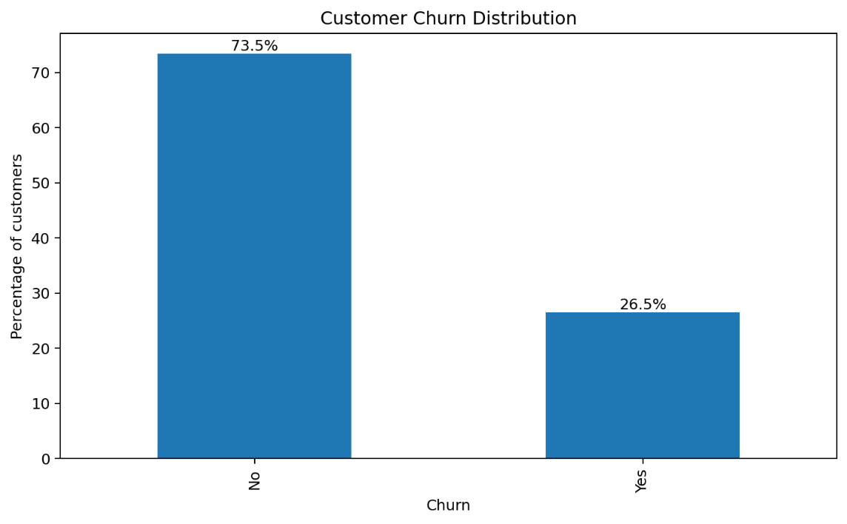
Cleaning and Preprocessing Decisions Made
- Converted TotalCharges from object/text to numeric and handled 11 missing/blank values using median imputation.
- Verified that no duplicate customer records were present.
- Standardized inconsistent service values such as No internet service and No phone service into No where needed for analysis/model preparation.
- Reviewed outliers in tenure, MonthlyCharges, and TotalCharges without automatically removing valid customer behavior.

  - EDA Key Insights
- Overall churn rate is 26.5%, which is a substantial customer loss risk.
- Month-to-month contract customers have a much higher churn rate (42.7%) than one-year (11.3%) and two-year customers (2.8%).
- Fiber optic customers have a higher churn rate (41.9%) than DSL customers (19.0%).
- Electronic check customers show the highest payment-method churn rate (45.3%).
- Senior citizens show higher churn (41.7%) than non-senior customers (23.6%).
- Customers with shorter tenure are more likely to churn, while longer-tenure customers are more stable.
- The cleaned dataset is ready for advanced analysis and feature engineering in Milestone 2.

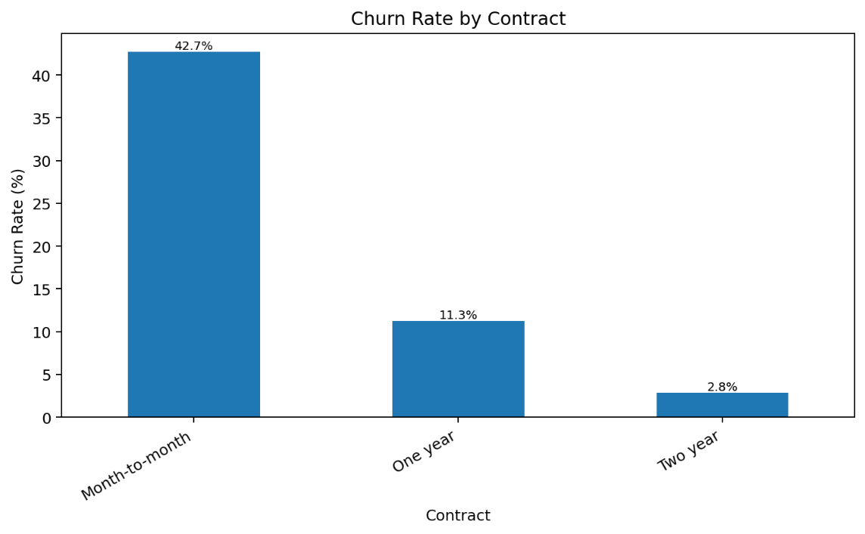
  - Business Implications
- The company should focus retention actions on new customers and month-to-month subscribers.
- Pricing and service-quality review is recommended for high-charge and fiber optic segments.
- Support and security services can be positioned as retention levers.

  - Deliverables (See Attachments Section)
- EDA Report: A document summarizing key insights from data exploration and preprocessing decisions.
- Interactive Visualizations: An EDA notebook showcasing visualizations that reveal key patterns and relationships.
- Cleaned Dataset: A dataset that is cleaned and prepared for machine learning.

Milestone 2: Advanced Data Analysis and Feature Engineering
- Objective:
Perform deeper data analysis and enhance feature selection and engineering to improve the model's predictive power.

- Advanced Statistical Analysis
Test | Features | Outcome
Independent T-Test | tenure, MonthlyCharges, TotalCharges | All tested numerical features showed statistically significant differences between churned and retained customers.
Chi-Squared Test | Contract, InternetService, PaymentMethod, OnlineSecurity, TechSupport | All tested categorical features showed strong relationships with churn.

- Feature Engineering Summary
Engineered Feature | Purpose | Expected Impact
Tenure Groups | Segments customers by loyalty stage | Improves interpretation of early-stage vs long-term churn.
Total Services | Counts subscribed services | Measures engagement and service adoption.
Average Monthly Spending | Calculates spending relative to tenure | Highlights customer value and billing behavior.
Charge Per Service | Measures cost intensity per subscribed service | Identifies customers paying high value for low service usage.
Long-Term Customer Flag | Classifies customers with tenure >= 24 months | Captures loyalty in a simple binary form.

- Encoding and Normalization
- Categorical variables were encoded using one-hot encoding.
- Boolean dummy variables were converted to numeric 0/1 values to support ML algorithms.
- Numerical features were normalized using MinMaxScaler so values remain non-negative between 0 and 1.
- customerID was excluded from modeling because it is an identifier, not a predictive feature.
- Feature Selection
- Random Forest feature importance was used to rank predictors.
- The final ML-ready selected dataset retains the top 15 most important features plus the Churn target column.
- This reduces weak predictors and keeps the next modeling phase more efficient and interpretable.
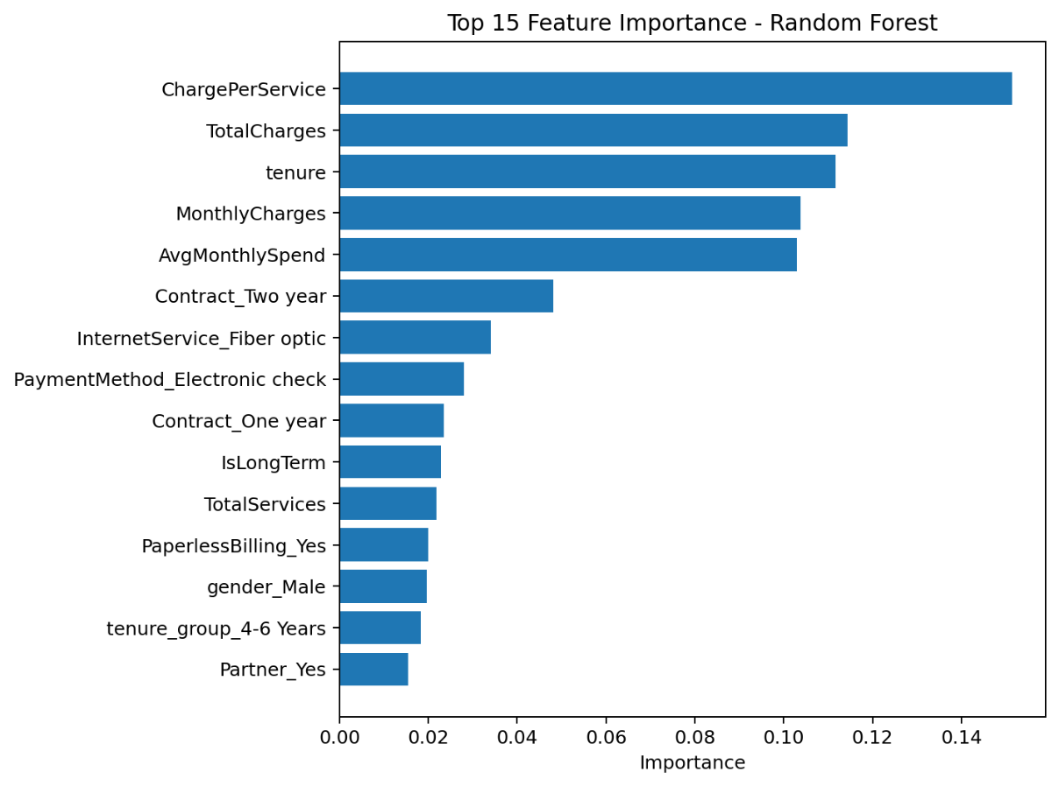
- Top 15 Selected Features
Rank | Feature
1 | ChargePerService
2 | TotalCharges
3 | tenure
4 | MonthlyCharges
5 | AvgMonthlySpend
6 | Contract_Two year
7 | InternetService_Fiber optic
8 | PaymentMethod_Electronic check
9 | Contract_One year
10 | IsLongTerm
11 | TotalServices
12 | PaperlessBilling_Yes
13 | gender_Male
14 | tenure_group_4-6 Years
15 | Partner_Yes

- Key Advanced Insights
- Contract type remains one of the strongest churn indicators: month-to-month customers churn at 42.7%.
- Payment method is highly relevant: electronic check customers churn at 45.3%.
- Higher charges, lower tenure, and weaker service engagement are important churn risk signals.
- Customers with more services and longer tenure show stronger retention behavior.

- Deliverables (See Attachments Section)
- Advanced data analysis report.
- Feature engineering summary.
- Full encoded and normalized dataset.
- Top 15 selected-features ML-ready dataset.
- Feature importance ranking CSV.

Milestone 3: Machine Learning Model Development and Optimization

- Objectives:
Build, train, and optimize machine learning models to predict churn.

- Activities Performed
- Train / test split + SMOTE
Stratified 80/20 split preserves the 73/27 churn ratio in both subsets. SMOTE is applied only to the training set so the test set still reflects real-world distribution.

- Baseline models — train and quick metrics
Five classifiers covering linear, ensemble, instance-based, and probabilistic approaches.
Evaluation Metrics used
Metric | Purpose
Accuracy | Overall prediction performance
Precision | Correct positive predictions
Recall | Ability to detect churn customers
F1-Score | Balance between precision and recall
ROC-AUC | Overall classification capability

- Five-Fold Stratified Cross-Validation (SMOTE applied per fold)
Wraps SMOTE inside an `imblearn.Pipeline` so synthetic minority samples never leak into the validation fold.

- Confusion matrices + classification reports
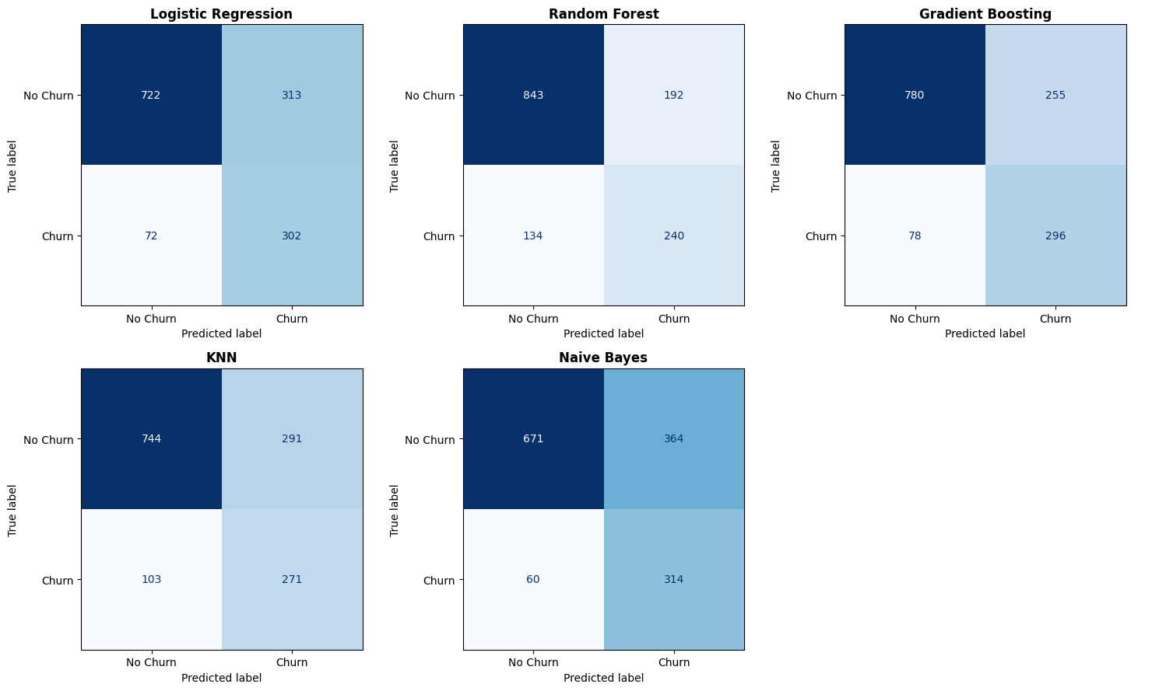
- Hyperparameter tuning — GridSearchCV
Tune the two strongest baselines: Gradient Boosting and Random Forest.
- Final comparison — baseline + tuned, on the held-out test set
================================================================================
FINAL MODEL COMPARISON (sorted by ROC-AUC)
================================================================================
Model Accuracy Precision Recall F1 ROC-AUC
Gradient Boosting (tuned) 0.7466 0.5145 0.8075 0.6285 0.8393
Gradient Boosting 0.7637 0.5372 0.7914 0.6400 0.8392
Logistic Regression 0.7268 0.4911 0.8075 0.6107 0.8331
Random Forest (tuned) 0.7700 0.5556 0.6684 0.6068 0.8218
Naive Bayes 0.6991 0.4631 0.8396 0.5970 0.8146
Random Forest 0.7686 0.5556 0.6417 0.5955 0.8120
KNN 0.7204 0.4822 0.7246 0.5791 0.7776

ROC curves — all models on one chart
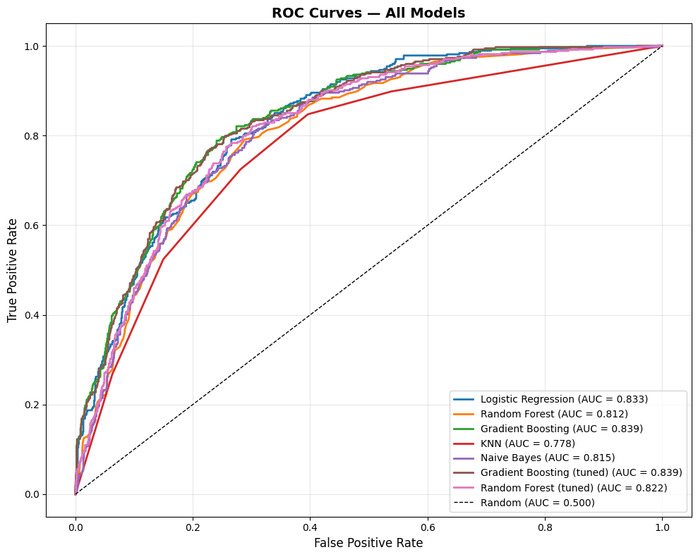

- Pick the winner — by F1
ROC-AUC ranks the untuned GB at the top, but tuned GB has higher F1 and recall on the churn class — which matter more for a retention use case.
Best model (by F1): Gradient Boosting
Test ROC-AUC = 0.8392 | F1 = 0.64

- Save the winning model + its metadata
We save TWO files that work as a pair:
1. The model itself -> .joblib (the actual "brain", saved with joblib)
2. Info about it -> .json (name, scores, settings, saved with json)

Model saved to: best_churn_model.joblib
Metadata saved to: best_churn_model_info.json

- Deliverables (See Attachments Section)
- Model Evaluation Report: A detailed report comparing model performance with evaluation metrics.
- Model Code: Python code used to train, optimize, and evaluate the models.
- Final Model: The best-performing churn prediction model, tuned and ready for deployment.

Milestone 4: MLOps, Deployment, and Monitoring
- Objectives:
- Implement MLOps practices and deploy the churn prediction model for real-time or batch predictions.
- Deliverables:
- Deployed Model: A fully functional API or cloud-deployed model that can make real-time churn predictions.
- MLOps Report: A report detailing the MLOps pipeline, experiment tracking, model deployment, and monitoring setup.
- Monitoring Setup: Documentation on how to track model performance and trigger updates or retraining.
- MLOps Pipeline Architecture
The implemented MLOps workflow includes:

- Experiment Tracking with MLflow
- Purpose of MLflow
MLflow was used to:
- Track experiments
- Store model parameters
- Log evaluation metrics
- Save trained models
- Compare multiple models runs

- Logged Parameters
Examples of tracked parameters:
Parameter
n_estimators
learning_rate
max_depth
random_state

- Logged Metrics
Examples of tracked metrics:
Metric
Accuracy
Precision
Recall
F1-Score
ROC-AUC

- Model Artifacts
MLflow stored:
- Trained models
- Scalers
- Evaluation results
- Experiment metadata
This improves reproducibility and model traceability.

- Model Serialization
The final model and preprocessing objects were saved using joblib.
Saved files:
- customer_churn_rf_model.pkl
- scaler.pkl
These files were later loaded during deployment.

- FastAPI Model Deployment
- Deployment Objective
The machine learning model was deployed as a REST API using FastAPI.
The API enables:
- Real-time predictions
- External system integration
- Scalable deployment architecture

- API Endpoints
Home Endpoint
GET /
Returns API status.

Prediction Endpoint
POST /predict
Accepts customer information and returns:
- Churn prediction
- Churn probability

- API Workflow

- Deployment in Google Colab
- The FastAPI application was deployed in Google Colab using:
- Uvicorn
- Ngrok
- Nest Asyncio
Ngrok was used to expose the local API server publicly.

- Swagger UI
FastAPI automatically generated interactive API documentation using Swagger UI.
Swagger UI enabled:
- Interactive endpoint testing
- Request validation
- JSON response visualization

- Streamlit Dashboard
A dashboard was built using Streamlit to allow interactive predictions.
https://depi4-ccpa.streamlit.app/
The dashboard includes:
- Numerical inputs
- Categorical dropdowns
- Real-time prediction results
- Churn probability visualization

Dashboard Features
Feature
User-friendly interface
Interactive controls
Real-time inference
Probability visualization
Input summary table

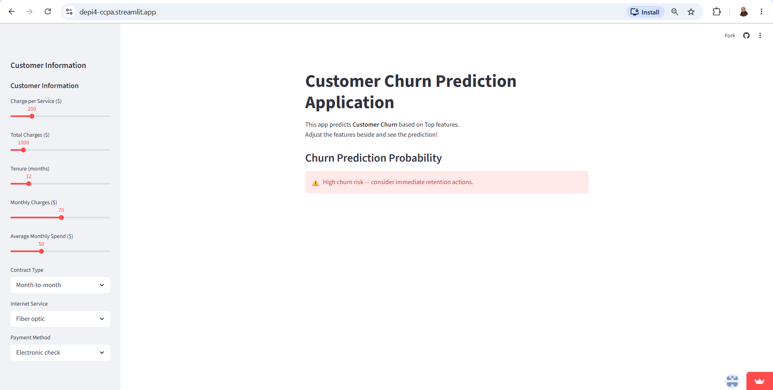

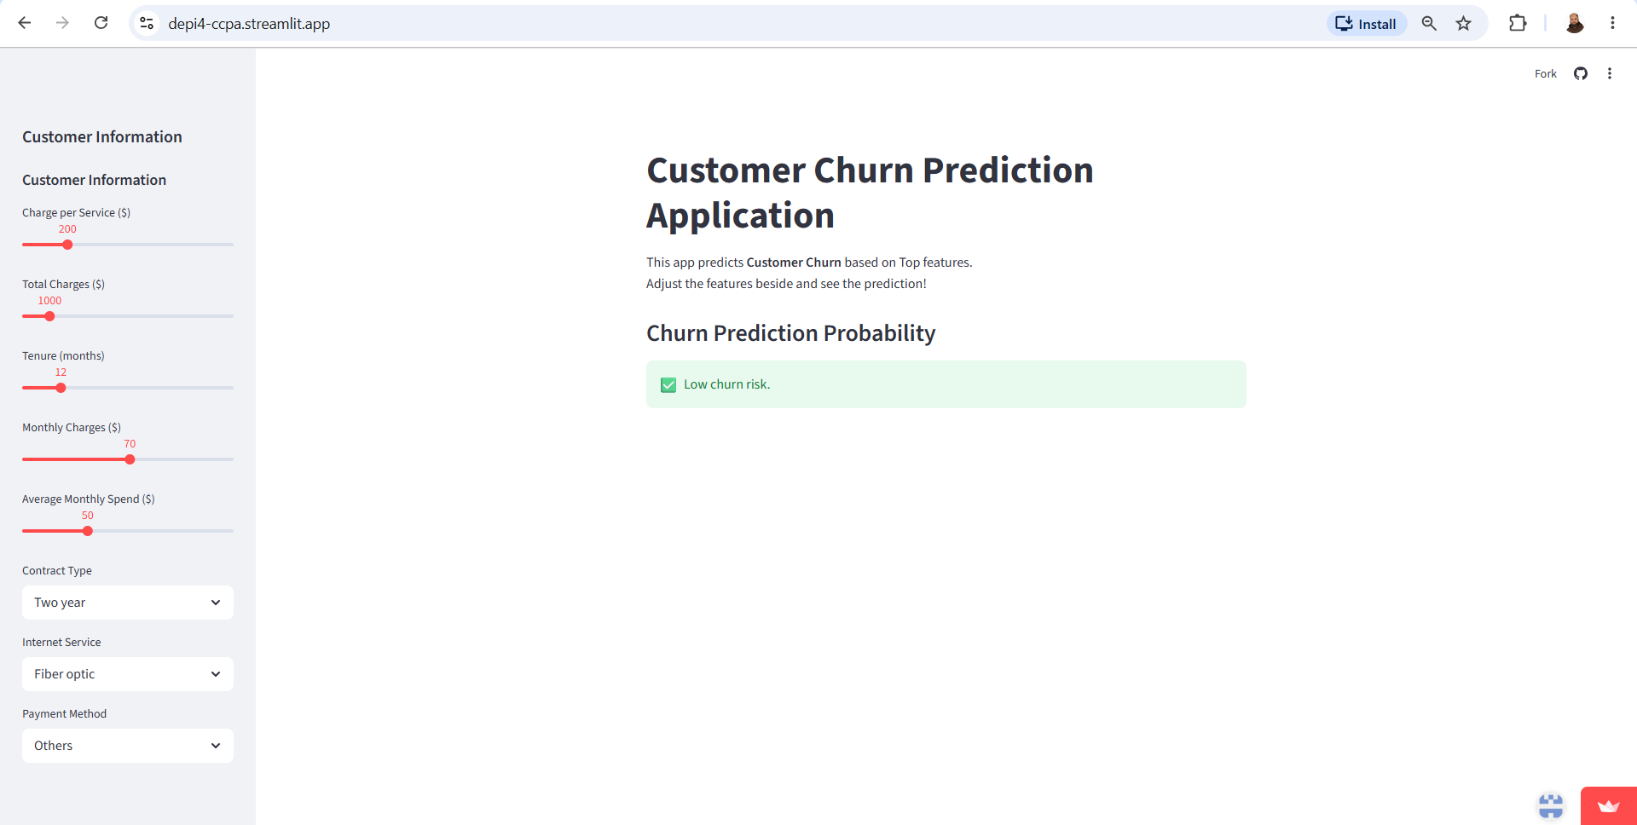

- Retraining Strategy
A retraining strategy was designed to maintain model performance over time.
- Retraining Triggers
Retraining occurs when:
- Accuracy drops below threshold
- Significant data drift is detected
- Customer behavior changes
- New features become available

- Retraining Workflow

- 13. Project Folder Structure

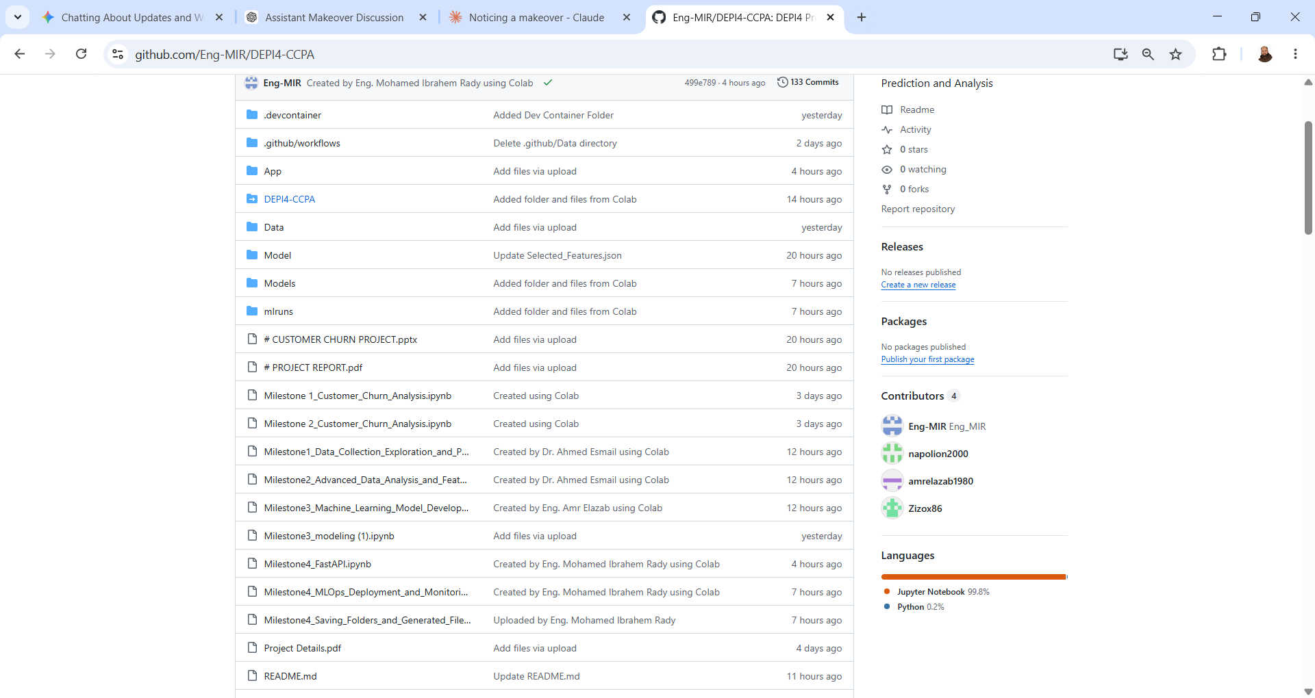

https://github.com/Eng-MIR/DEPI4-CCPA/

DEPI4-CCPA/
│
├── App/
├── FastAPI_app.py
├── streamlit_application.py
├── Data/
├── WA_Fn-UseC_-Telco-Customer-Churn.csv
├── Models/
├── customer_churn_rf_model.pkl
├── customer_churn_xgb_model.pkl
├── scaler.pkl
├── mlruns/
├── README.md
└─── requirements.txt

- Deliverables (See Attachments Section)
- Deployed Model: A fully functional API or cloud-deployed model that can make real-time churn predictions.
- MLOps Report: A report detailing the MLOps pipeline, experiment tracking, model deployment, andmonitoring setup.
- Monitoring Setup: Documentation on how to track model performance and trigger updates or retraining

Milestone 5: Final Documentation and Presentation
- Objectives:
• Prepare final documentation and create a presentation for stakeholders that showcases the project's results and business impact.
- Deliverables (See Attachments Section)
• Final Project Report: A detailed summary of the project’s process, from data collection to deployment, and the business impact of churn prediction.
• Final Presentation: A polished presentation for business stakeholders, explaining the model’s value and usage.

Conclusions & Recommendations:

# | Conclusion | Recommendation
1 | The churn rates between males and females are nearly identical, suggesting that gender may not be a significant factor influencing churn in this dataset. | Retention strategies should target both genders with the same interest.
2 | The presence of a partner appears to be associated with higher customer retention. | Targeted retention strategies for customers without partners could help reduce overall churn rates.
3 | The presence of dependents appears to be associated with higher customer retention. | Targeted retention strategies for customers without dependents could help reduce overall churn rates.
4 | The presence of phone service (regardless of multiple or single lines) is associated with slightly better retention compared to those without phone service. | The marketing team should implement new campaigns to encourage customers to get phone services and to encourage other customers to get multiples lines.
5 | The type of internet service significantly impacts churn behavior, with fiber optic customers being more likely to churn. | - Implement targeted retention strategies for fiber optic customers.  - Improve service quality for fiber optic customers to reduce dissatisfaction.
6 | Only 29% of the customers have online security, indicating a relatively low adoption rate among those with internet service. | This suggests a need for increased awareness or incentives to adopt security measures among internet customers.
7 | Customers with online security exhibit a lower churn rate (15%), indicating better retention compared to Customers without online security. | This suggests that enhancing online security measures could improve customer retention.
8 | The low adoption of online backup suggests potential risks and a need for increased awareness or incentives to adopt backup solutions among internet users. | This suggests that promoting online backup solutions could improve customer retention.
9 | The low adoption of device protection suggests potential risks and a need for increased awareness or incentives to adopt protection. | This suggests that promoting device protection solutions could improve customer retention.
10 | The low adoption of tech support suggests potential challenges and a need for increased awareness or incentives to adopt tech support services among internet users. | We recommend promoting tech support services for customers as it could significantly improve customer retention.
11 | The presence of streaming movies is associated with slightly lower churn rates. | We recommend adjusting new pricing models for streaming movies services.
12 | The high prevalence of month-to-month contracts suggests a need to focus on retention strategies for this group, as they may be more likely to churn compared to those with longer-term contracts. | We recommend encouraging customers to switch to longer-term contracts as it could significantly reduce churn rates and improve customer retention.
13 | The high adoption of paperless billing suggests that digital communication channels are widely accepted and could be leveraged for further customer engagement and retention strategies. | We recommend migrating paper billing services to be paperless to maintain the same experience for the majority of customers.
14 | The relationship between tenure and churn rate highlights the importance of customer retention strategies, particularly for newer customers. | - Investigate the reasons behind higher churn rates among customers with shorter tenures (e.g., onboarding process, initial customer experience).  - Develop loyalty programs and engagement strategies to improve retention for newer customers.  - Encourage longer contract commitments by offering discounts or loyalty benefits.
15 | The diversity in payment methods suggests that customers have varied preferences, and understanding these preferences can help in tailoring payment-related services and communications. | Provide incentives for electronic check users to switch to more stable payment methods.
16 | There are higher churn rates among customers with no value-added services (security, backup, tech support) compared to other customers with such services. | Promote value-added services (security, backup, tech support) to increase retention.

Action Plan to Improve Customer Churn Rates

  - Improve Customer Satisfaction & Engagement
Action Steps:
- Conduct customer satisfaction surveys and analyze feedback.
- Improve customer technical support responsiveness, reducing complaint resolution time.
Expected Outcome:
Stronger relationships with customers, reducing dissatisfaction-driven churn.

  - Optimize Pricing & Service Offerings
Action Steps:
- Create more new pricing models.
- Offer discounts or loyalty programs to customers at risk of churning.
- Introduce flexible contract options (e.g., month-to-month vs. long-term).
Expected Outcome:
A competitive pricing strategy that retains price-sensitive customers.

  - Strengthen Retention Strategies
Action Steps:
- Implement a proactive retention program targeting customers with high churn probability.
- Launch exclusive offers for long-term customers, such as free service upgrades.
- Monitor early warning signs (e.g., reduced usage, late payments) and reach out before customers leave.
Expected Outcome:
Increased retention of high-value customers through proactive engagement.

  - Enhance Customer Onboarding
Action Steps:
- Improve the onboarding process and make it easy with clear instructions and tutorials for new customers.
- Conduct welcome calls or emails to ensure customers are fully aware of available services.
Expected Outcome:
Higher initial engagement, reducing early-stage churn and increased tenure durations.

  - Improve Service Quality & Offer Additional Value
Action Steps:
- Analyze service performance metrics (e.g., downtime, speed, quality issues).
- Invest in infrastructure improvements for better reliability.
- Introduce value-added services such as premium support or exclusive content.
Expected Outcome:
Enhanced customer satisfaction, making customers less likely to switch to competitors.

  - Leverage Data & Predictive Analytics
Action Steps:
- Continuously monitor churn trends using dashboards in Power BI or other analytics tools.
- Use machine learning models to predict churn and take early action.
Expected Outcome:
A data-driven approach to churn management, allowing for quick and effective interventions.

Attachments:

  - M1- Telecom dataset.csv
  - M1-2- Milestone 1 & 2_Customer_Churn_Analysis.ipynb
  - M1- final_cleaned_encoded_normalized_customer_churn.csv
  - M2- feature_importance_ranking.csv
  - M1- final_top15_selected_features_customer_churn.csv
  - All Project Visualizations.pdf
  - M3- Modeling.ipynb
  - M3- best_churn_model.joblib
  - M3- best_churn_model_info.json
  - M4- FastAPI_app .py
  - M4- Milestone4_FastAPI.ipynb
  - M4- streamlit_application.py
  - Project Presentation.pptx
  - Project Report.pdf

